Project 2: Temperature Readings on a Thermistor

David Wittsack
EN.605.715 Software Development for Real-Time Embedded Systems
Professor Doug Ferguson
September 11, 2022

Contents
Video Link 3
Requirements 3
Design 3
Implementation 5

Video Link
At the link below you can view a video demonstration of my working project:
https://youtu.be/g1Q3EA3D8RM

Requirements
The project has the following set of requirements:
- The system shall have a round robin with interrupts architecture.
- The software will coded in c++ and uploaded onto an Arduino device.
- A circuit must be designed to take temperature readings using a thermistor.
- The system may need to be calibrated to more accurately read temperature data.
- Temperature readings must be taken over a period of time, with readings taken every 10 seconds.
  - First, 5 minutes of readings at room temperature.
  - Next, 5 minutes of temperature readings while in the fridge.
  - Lastly, an additional 5 minutes of readings at room temperature.
- The data must be exported as CSV and a chart of the data should be produced.

Design
The system’s primary component is an NTC 103 thermistor.

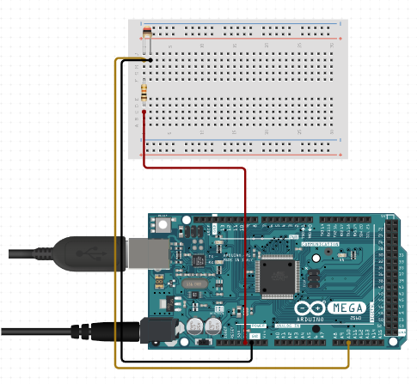
Figure 1. Thermistor Circuitry

Implementation

